
ORDINANCE NO. 2008-04
AMENDING ORDINANCE #3A OF 1973 WHICH ESTABLISHED THE
SANTA CRUZ COUNTY ZONING AND DEVELOPMENT CODE

WHEREAS, on May 21, 1973, the Board of Supervisors (the “Board”) adopted the Santa Cruz County Zoning Ordinance of 1973 which became effective on October 5, 1973; and,

WHEREAS, on April 5, 1982, the Board adopted the Outdoor Light Control Code; and,

WHEREAS, Arizona Revised Statutes §11-251.35 provides counties with the authority to regulate outdoor lighting; and,

WHEREAS, the Board has considered additional amendments to the adopted regulations, after public hearings were held before the Planning and Zoning Commission (the “Commission”) and the Board; and,

WHEREAS, the Commission held a public hearing on March 21, 2008 and at the conclusion of that hearing voted unanimously to recommend approval of new outdoor lighting regulations; and,

WHEREAS, the Board held a public hearing on June 11, 2008 to take input on proposed new outdoor lighting regulations.

NOW, THEREFORE, BE IT ORDAINED that effective on the 11th day of July, 2008 Article 28 of the Zoning and Development Code shall be added as follows:

BEGIN AMENDMENT

Add to Table of Contents:

ARTICLE 28 – OUTDOOR LIGHTING REGULATIONS (with appropriate page number)

After Article 24 add:

ARTICLE 28 - OUTDOOR LIGHTING ARTICLE
--2801—ADMINISTRATION
--2802—DEFINITIONS
--2803—GENERAL REQUIREMENTS
--2804—PROHIBITIONS
--2805—TEMPORARY EXEMPTIONS
--2806—OTHER EXEMPTIONS
--2807—OUTDOOR ADVERTISING SIGNS
--2808—SPECIAL USES
--2809—LAW GOVERNING CONFLICTS
--2810—CONDITIONAL USE PERMIT

SEC. 2801 ADMINISTRATION

A. Purpose and Intent
1. The purpose of this Article is to preserve the relationship of the residents of Santa Cruz County to their unique desert environment through protection of access to the dark night sky. Intended outcomes include continuing support of astronomical activity and minimizing wasted energy, while not compromising the safety, security, and well being of persons engaged in outdoor night time activities.
2. It is the intent of this Article to control the obtrusive aspects of excessive and careless outdoor lighting usage while preserving, protecting, and enhancing the lawful nighttime use and enjoyment of any and all property. It is recognized that portions of properties may be required to be unlit, covered, or have reduced lighting levels in order to allow enough lumens in the lighted areas to achieve light levels in accordance with nationally recognized recommended practices.
B. Applicability
1. New Uses, Buildings and Major Additions or Modifications.
a) This Article applies to any and all new and major additions to land uses, developments, buildings, or structures.
b) If a major addition occurs on a property, the entire property shall comply with this Article. For purposes of this section, the following are considered to be major additions:
1) Additions of 25 percent or more in terms of additional dwelling units, gross floor area, seating capacity, or parking spaces, either with a single addition or with cumulative additions subsequent to the effective date of this provision.
2) Single or cumulative modification or replacement of outdoor lighting fixtures legally installed constituting 25 percent or more of the actual lumens for the property, no matter the actual amount of lighting already on a non-conforming site, constitutes a major addition for purposes of this Section. Where existing outdoor lighting is modified or replaced and the resulting lighting fixture has less lumen capacity than the previously existing fixture, the lumen capacity of the modified or replaced fixture shall not be included in the lumen calculations for determining a major addition, but the total of non-conforming lighting shall not be increased.
2. Minor Additions. Additions or modifications greater than 10% but less than 25 percent to existing uses shall require the submission of a complete inventory and site plan detailing all existing and any proposed new outdoor lighting. Any new lighting on the site shall meet the requirements of this Article with regard to shielding and lamp type; the total amount of lighting after the modifications are complete shall not exceed that on the site before the modification, or that permitted by this Article, whichever is larger.
3. Change of Use. Whenever the use of a portion of any existing building or any building, structure, or premises is changed to a new use, all outdoor lighting related to the new use shall be reviewed and brought into compliance with this Article before the new use commences.
4. Resumption of Use after Abandonment. If a property or use with non-conforming lighting is abandoned as defined in Section 2802.R, then all outdoor lighting shall be reviewed and brought into compliance with this Article before the use is resumed.
C. Approved Materials and Methods of Construction or Installation. The provisions of this Article are not intended to prevent the use of any design, materials or method of installation or operation not specifically prescribed by this Article, provided any such alternate has been approved. The Director may approve any such proposed alternate provided he/she finds that it:
1. Provides at least approximate equivalence to the applicable specific requirements of this Article; and
2. Is otherwise satisfactory or complies with the intent of this Article; and has been designed or approved by a registered lighting or electrical engineer and is supported by calculations showing that the design submitted meets that intent of the Article. This section shall not have the effect of waiving the lumen caps and shielding requirements of this Article.
D. Appeals. Any person aggrieved by any decision of the Director made in administration of this Article has the right and responsibilities of appeal to the Board of Adjustment as per Sec. 606 and Sec. 608 of this Code.
SEC. 2802 DEFINITIONS
Unless the context clearly indicates otherwise, certain words and phrases used in this Article mean the following:
A. County Lighting Area. All of the unincorporated area of Santa Cruz County.
B. Decorative Lighting. Any outdoor lighting used for decorative effects including, but not limited to, architectural illumination, flag and monument lighting, and illumination of landscaping.
C. Development Project. Any residential, commercial, industrial or mixed use subdivision plan or development plan which is submitted for approval or for permit.
D. Direct Illumination. Illumination resulting from light emitted directly from a lamp or luminaire, not light diffused through translucent signs or reflected from other surfaces such as the ground or building faces.
E. Director. The Director of Community Development or his/her designee.
F. Display Lot or Area. Outdoor areas where active nighttime sales activity occurs and where accurate color perception by customers is required. To qualify as a display lot, one of the following specific uses must occur: automobile sales, assembly lots, swap meets, airport and automobile fueling areas. Uses not on this list must be approved as a display lot use.
G. Fully Shielded. (FS) An opaque, permanent, nontransparent, shielding on all sides which extends below the light source and lens or diffusers. This luminaire shielding shall be permanently attached. [See Figure 1]
H. Installed. The attachment, or assembly, fixed in place, whether or not connected to a power source, of any outdoor light fixture.
I. Lumen. Unit of luminous flux; used to measure the amount of light emitted by lamps.
J. Luminaire. The complete lighting assembly, less the support assembly. For purposes of determining total light output, luminaire lighting assemblies which include multiple unshielded or fully shielded lamps on a single pole or standard shall be considered as a single unit. Two or more units with lamps less than 3 feet apart shall be considered a single luminaire.
K. Net Acreage. The remaining ground area after deleting all portions for proposed and existing public streets within a development, parcel, or subdivision. For commercial or industrial lots use the lot square footage to determine Net Acreage. This percentage shall be used to determine the total lumens from Table 2800-1. The net acre percentage does not apply for residential zoning caps for Table 2800-1.
L. Opaque. Opaque means that the material shall not transmit visible light.
M. Outdoor light fixture. An outdoor illuminating device, outdoor lighting or reflective surface, lamp or similar device, permanently installed, or portable, used for illumination or advertisement. Such devices shall include, but are not limited to:
1. Street lighting;
2. Parking lot lighting;
3. Building and structural lighting;
4. Landscape lighting;
5. Recreational lighting;
6. Billboards and other signs (advertising or otherwise)
7. Product display area lighting;
8. Building overhangs and open canopies;
9. Security lighting;
10. Searchlights, spotlights, flood lights, and laser lights.
N. Outdoor Light Output, Total. The total amount of light, measured in lumens, from all outdoor light fixture lamps, is calculated as follows:
1. The initial lumen output, as defined by the lamp manufacturer, shall be the lumen value used.
2. The total light output of each outdoor light fixture shall be based on the largest lamp that the outdoor light fixture is rated to accommodate. For the purpose of compliance with this section, the largest lamp rating for fluorescent and high intensity discharge fixtures shall be based on the installed ballast rating.
3. Using Table 2800-1, total lumens per acre for a Commercial or Industrial site, Options 1 & 2, shall be figured as a percentage of net acres. For example, a site with .5 net acres would have a lumen cap of 37,500 for Option 1 and a cap of 30,000 for Option 2. A site with 2 net acres would have a cap of 150,000 lumens for Option 1 and 120,000 for Option 2.
4. The net acre percentage does not apply for residential zoning lumen caps for Table 2800-1.
O. Outdoor Recreation Facility. An area designed for active recreation, whether publicly or privately owned, including, but not limited to baseball, soccer, football, golf, tennis, swimming pools, roping arenas and race tracks of any sort.
P. Person. Any individual, tenant, lessee, owner, or any commercial entity including but not limited to a firm, business, partnership, joint venture or corporation.
Q. Temporary Lighting. Lighting which does not conform to the provisions of this Article and which will not be used for more than one thirty (30) day period within a calendar year, with one thirty (30) day extension. Temporary lighting is intended for uses which by their nature are of limited duration; e.g. for example holiday decorations, civic events, or construction projects.
R. Use, Abandonment of. The relinquishment of a property, or the cessation of a use or activity by the owner or tenant for a period of six months, excluding temporary or short term interruptions for the purpose of remodeling, maintaining, or otherwise improving or rearranging a facility. A use shall be deemed abandoned when such use is suspended as evidenced by the cessation of activities or conditions which constitute the principal use of the property.

SEC. 2803 GENERAL REQUIREMENTS
A. Applicability. The table in this Section gives requirements of the total light output permitted per acre excluding designated natural open space as defined in this Code for the different lighting options. These requirements shall be met for all lighting installations subject to this Article.
B. Total Outdoor Light Output. Total outdoor light output shall not exceed the lumen limits given in Table 2800-1. In the table, Total means the sum of shielded and unshielded exterior lighting.

Table 2800-1: Maximum Total Outdoor Light Output Requirements Per Acre - Lumen Caps
 | Total Lumens Permitted Per Acre (excluding designated natural open space)
Option 1 - Commercial and Industrial - (1)(2)(5)(Mostly Low Pressure Sodium - LPS)
Total (FS LPS, plus FS non-LPS, unshielded) | 75,000
Limit on non-LPS FS | 3,000
Limit on unshielded components, LPS or Non-LPS lighting | 3,000
Option 2 - Commercial and Industrial - (1)(2)(5)
Total lumens (FS, plus unshielded) | 60,000
Limit on unshielded components | 3,000
Option 3 - All Residential zoning (3)(4)
Total (FS plus unshielded) Lots one acre or larger | 20,000
Limit on unshielded component | 3,000
Total (FS plus unshielded) Lots less than one acre | 10,000
Limit on unshielded component | 3,000
Notes to Table 2800-1
1. Use either option 1 or 2 for the entire property.
2. This applies to all land-use zoning classifications for multiple family triplexes and larger, commercial, and industrial sites.
3. This applies to all residential land-use zoning, including all densities and types of housing, such as single family detached and duplexes.
4. If LPS is used for residential lighting, then the total lumens in the table can be increased by 50 percent of FS plus unshielded lighting. For example, for lots one acre or larger, the total lumens could be 30000 of FS LPS including 3000 of non-LPS (which could include 3000 of non-FS). The grand total shall not exceed 30000 lumens.
5. Lumens per Net Acre; Unshielded lumen caps shall not increase regardless of acreage.

C. Lamp Type and Shielding Standards.
1. All Outdoor light fixtures shall be fully shielded (FS) except:
a) Residential flood or spot lamps shall be shielded and shall be aimed no higher than 45 degrees to the horizontal (half-way between straight down and horizontal) when the source is visible from any adjacent residential property in order to minimize light trespass.
b) Seasonal decorations using unshielded incandescent lamps shall be permitted from Thanksgiving to January 15th.
c) Neon lighting.
d) 3000 lumen exemption as per Table 2800-1
2. In the shielding requirements of this Article, all light fixtures on the residential side of commercial property adjacent to residential property shall be fully shielded and shall be a maximum of 5 feet above grade at the property line and no higher than a line rising 25 degrees above the 5 feet until 100 feet from the property line. All outdoor lighting within one mounting height of residential areas shall have internal house-side shields. (See Figure 2.) Appendix A contains examples of acceptable and unacceptable lighting fixtures for use in complying with this Article.
D. Conformance with Applicable Articles. All outdoor illuminating devices shall be installed in conformance with the provisions of this Article and any building or electrical Articles adopted by the County as applicable with appropriate permitting and inspections.
E. Submission of Plans and Evidence of Compliance with Article.
1. Submission Contents. The applicant for any permit required by any provision of the laws of this jurisdiction in connection with proposed work involving outdoor lighting fixtures shall submit (as part of the application for permit) evidence that the proposed work will comply with this Article. The submission shall contain but shall not necessarily be limited to the following, all or part of which may be part or in addition to the information required elsewhere in the laws of this jurisdiction upon application for the required permit:
a) Indicate the location of luminaries on the site plan; submit an electrical exterior lighting schedule showing the following:
1) The type of illuminating device, LPS, HPS, Fluorescent, Incandescent, Metal Halide, Halogen, etc.
2) Number of lamps
3) Total lumens per type (refer to Table 2800-2 for standard values by type and wattage)
4) Indicate if each device is fully shielded
5) Show total exterior lumens planned for the site
6) Show total net acreage of site
7) Indicate the Option you are using from Table 2800-1 and total lumen cap allowed for your option in Table 2800-1.
b) Description of the illuminating devices, fixtures, lamps, supports, reflectors, and other devices. The description may include, but is not limited to, catalog cuts by manufacturers and drawings (including sections where required);
c) Photometric data, such as that furnished by manufacturers, or similar showing the angle of cutoff of light emissions. Photometric data need not be submitted when the full cutoff performance of the fixture is obvious to the reviewing official.
2. Additional Submission. The above required plans, descriptions and data shall be sufficiently complete to enable the plans examiner to readily determine whether compliance with the requirements of this Article will be achieved. If such plans, descriptions and data cannot enable this ready determination, by reason of the nature or configuration of the devices, fixtures, or lamps proposed, the applicant shall additionally submit as evidence of compliance such certified reports of tests that will, provided that these tests shall have been performed and certified by a recognized testing laboratory.
3. Subdivision Plat Certification. If any subdivision proposes to have installed street or other common or public area outdoor lighting, the final plat shall contain a statement certifying adherence to the applicable provisions of this Article.
4. Lamp or Fixture Substitution. Should any outdoor light fixture or the type of light source therein be changed after the permit has been issued, a change request must be submitted to the design professional and Director for his/her approval, together with adequate information to assure compliance with this Article, which must be received prior to substitution.
SEC. 2804 PROHIBITIONS
A. Mercury Vapor Lamps Fixtures and Lamps. The installation, sale, offer for sale, lease or purchase of any mercury vapor lamp for use as outdoor lighting is prohibited.
B. Laser Source Light. The use of laser source light or any similar high intensity light for outdoor advertising or entertainment, when projected above the horizontal, is prohibited.
C. Signs. Bottom or up-lighting of exterior signs is prohibited.
D. Searchlights. The operation of searchlights for advertising purposes is prohibited.
SEC. 2805 TEMPORARY EXEMPTIONS
A. Information Required. Any person may submit a written request to the Director for a temporary exemption of the requirements of this Article. A temporary exemption request shall contain the following information:
1. Specific exemption or exemptions requested;
2. Type and use of outdoor light fixture involved;
3. Duration of time of the requested exemption;
4. Type of lamp and lamp lumens;
5. Total wattage of lamp or lamps and number of lamps to be used;
6. Proposed location on premises of the outdoor light fixture(s);
7. Previous temporary exemptions, if any, and addresses of premises there under;
8. Physical size of outdoor light fixture(s) and type of shielding provided;
9. Such other data and information as may be required by the Director.
A. Approval; Duration. The County shall have ten business days from the date of submission of the request for temporary exemption to act, in writing, on the request. If approved, the exemption shall be valid for not more than thirty days from the date of issuance of the approval. The approval shall be renewable at the discretion of the Director upon a consideration of all the circumstances. Each such renewed exemption shall be valid for not more than thirty additional days.
B. Disapproval; Appeal. If the request for temporary exemption is disapproved, the person making the request will have the appeal rights provided in Section 2801.D.
SEC. 2806 OTHER EXEMPTIONS
A. Non-conformance. All other outdoor light fixtures lawfully installed prior to and operable on the effective date of the ordinance that codified in this Article are exempt from all requirements of this Article. There shall be no change in use or lamp type, or any replacement or structural alteration made, without conforming to all applicable requirements of this Article. Further, if the property is abandoned, or if there is a change in use of the property, the provisions of this Article will apply when the abandonment ceases or the new use commences.
B. Neon lighting is exempt from the requirements of Sections 2803.A and B when used for sign lighting, but not for other uses. Natural gas lighting is exempt from all requirements of this Article.
C. Federal and State Facilities. Those facilities and lands owned or operated by the U. S. Federal Government or the State of Arizona are exempted by law from all requirements of this Article. Voluntary compliance with the intent of this Article at those facilities is encouraged.
SEC. 2807 OUTDOOR ADVERTISING SIGNS
A. External illumination for on-site signs shall conform to all provisions of this Article. In particular, such lighting shall conform to the lamp source, shielding restrictions, and lumen caps of Section 2803. All upward-directed, bottom-mounted, sign lighting is prohibited.
B. Illumination of legal non-conforming off-site signs not illuminated at the effective date of this Article is prohibited.
C. Outdoor internally-illuminated advertising signs shall not be counted towards the lumen cap and shielding requirements described in Table 2800-1. Outdoor internally illuminated advertising signs constructed with an opaque or colored background and translucent text and symbols are strongly preferred so as to reduce any potential detrimental effects due to such signs.
D. Illumination for all advertising signs, both externally-illuminated and internally- illuminated, shall be turned off at close of business. No externally-illuminated signs shall be allowed in residential areas.
SEC. 2808 SPECIAL USES
A. Recreational Facilities.
1. All site lighting not directly associated with the athletic playing areas shall conform to the lighting standards described in this Article, including but not limited to the lamp type and shielding requirements of Section 2803 and the lumens per acre limits of Table 2800-1.
2. Lighting for athletic fields, courts or tracks shall be exempt from the lumens per acre limits of Table 2800-1. All such lighting shall utilize fully shielded luminaires installed in a fashion that maintains the full cutoff characteristics unless certified by a registered engineer that such shielding is impractical. Every such lighting system design shall be certified by a registered engineer as conforming to all applicable restrictions of this Article. Where full cutoff fixtures are not utilized, acceptable luminaires shall include those which:
a. Are provided with internal and/or external glare control louvers and installed so as to limit direct up-lighting to less than 5 percent of the total lumens exiting from the installed fixtures and minimize offsite light trespass as required in 2 above, and;
b. Are installed with minimum aiming angles of 25 degrees downward from the horizontal. Said aiming angle shall be measured from the axis of the luminaire maximum beam candlepower as certified by an independent testing agency.
c. All events shall be scheduled so as to complete all activity by 11 p.m. Illumination of the playing field, court or track shall be permitted after the curfew only to conclude a scheduled event that was unable to conclude before the curfew due to unusual circumstances.
B. Outdoor Display Lots
Lighting for display lots shall comply with the following standards and Table 2800-1.
1. All such lighting shall utilize fully shielded luminaires that are installed in a fashion that maintains the full cutoff characteristics. Every such lighting system design shall be certified by a registered lighting or electrical engineer as conforming to all applicable restrictions of this Article.
2. All site lighting not directly associated with the display areas shall conform to the lighting standards described in this Article, including but not limited to the lamp type, shielding requirements, and the lumens per acre limits of Table 2800-1.
3. Lot lighting shall be turned off at close of business.
C. Service Station Under-Canopy Lighting
Lighting for service station canopies shall be turned off at the close of business.
1. Shielding: All luminaires are to be flush with, or recessed into the lower surface of service station canopies and shall be fully shielded and utilize flat lenses to minimize light trespass.
2. Total Under-Canopy Output: The total light output used for illuminating service station canopies is defined as the sum of all under-canopy initial bare lamp outputs in lumens and shall not exceed 40 lumens per square foot of canopy. Twenty-five percent (25%) of the lumens from fully shielded outdoor lighting fixtures installed under canopies shall be counted toward the lumens caps.
3. Illuminated canopy margins shall be considered in the total lumen count per acre.
D. Wireless Communications Towers
If tower lighting is required, it shall be the least obtrusive that meets Federal Aviation Administration and County requirements.
SEC. 2809 LAW GOVERNING CONFLICTS
Where any provision of federal, state, or local statutes, Articles, or laws conflicts with any provision of this Article, the most restrictive shall govern unless otherwise regulated by law.
SEC. 2810 CONDITIONAL USE PERMIT.
The lumen cap provisions of this Article, in Table 2800-1, may be altered, varied, or modified by the issuance of a Conditional Use Permit by the Board of Adjustment, as per Article 6 of this Code, upon a finding by the Board that such alteration, variance, or modification is necessary for the proposed use of the subject property because of increased security requirements, public safety, or public need and that the purpose and intent of this Article are reasonably accommodated. In addition to the applicable public hearing notice requirements of Article 6, Sec. 610 of this Code, written notice of public hearings shall be given stating the time, date and purpose of the hearing to the F.L. Whipple Observatory or its successor or equivalent and to owners of property within one thousand feet of the subject property.
SEC. 2811 ENFORCEMENT AND PENALTY.
It shall be the duty of the Director to administer and enforce this Article. All other County law enforcement officials and agencies shall, whenever requested by the Director, participate in and assist in the enforcement of this Article to the extent that they are lawfully authorized to do so.
Any violation of this Article, or any portion of this Article, shall be considered a civil violation and is subject to penalties not to exceed the amount of the maximum fine for a class 2 misdemeanor in accordance with A.R.S. §11-808. Each day of continuance of the violation constitutes a separate violation. Maximum fines are $750.00 for individuals and $10,000.00 for corporations, associations, labor unions or other legal entities. Enforcement procedures shall be pursuant to those established by the Department of Community Development.

[Figure 1]

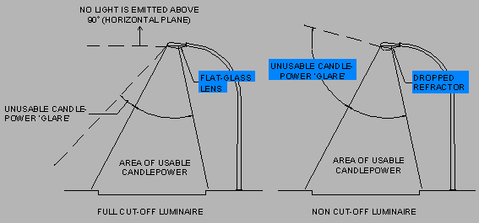

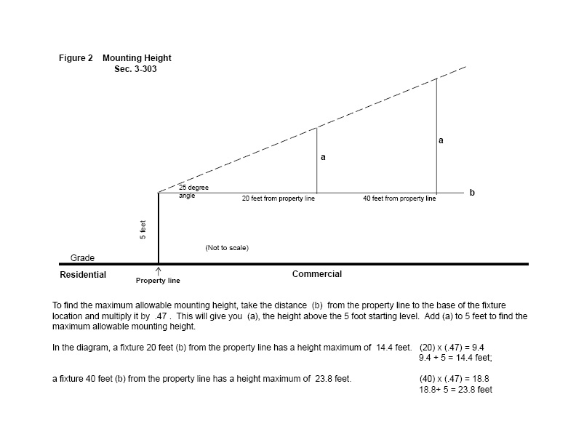

TABLE 2800-2 – Standards values based on manufacturer’s data – to be used unless applicant submits other verified lumen values.
Type | Lamp Wattage | Initial Lumens
Incandescent | 25 W | 150
 | 40 W | 460
 | 60 W | 890
 | 75 W | 1210
 | 100 W | 1750
 | 150 W | 2880
 | 300 W | 6360
 | 1000 W | 23800
Compact Florescent | 5 W | 250
 | 7 W | 400
 | 13 W | 900
 | 18 W | 1200
 | 26 W | 1800
 | 32 W | 2900
Tungsten-Halogen | 250 W | 4700
 | 500 W | 10700
 | 1000 W | 19000
 | 1500 W | 36000
Metal Halide | 175 W | 14000
 | 250 W | 20000
 | 400 W | 40000
 | 1000 W | 115000
PAR (Parabolic Aluminized Floods & Spots) | 150 W | 1740
HPS (High Pressure Sodium) | 50 W | 3300
 | 70 W | 5800
 | 100 W | 9500
 | 150 W | 16000
 | 200 W | 22000
 | 250 W | 30000
 | 310 W | 37000
 | 400 W | 50000
 | 1000 W | 140000
LPS ( Low Pressure Sodium) | 18 W | 1800
 | 35 W | 4800
 | 55 W | 8000
 | 90 W | 13500
 | 135 W | 22500
 | 180 W | 33000
Fluorescent (Standard Cool White, 1.5-inch tubes) | 21 W | 1190
 | 30 W | 2050
 | 36 W | 2450
 | 39 W | 3000
 | 50 W | 3700
 | 52 W | 3900
 | 55 W | 4600
 | 70 W | 5400
 | 75 W | 6300

Appendix A
Examples of fixtures that are NOT Fully Shielded  (Note: Some of these fixtures may be acceptable provided they don’t exceed 1,000 lumens.) | Examples of fixtures that are Fully Shielded  (Note: to be fully shielded these fixtures must be closed on top and mounted such that the bottom opening is horizontal)
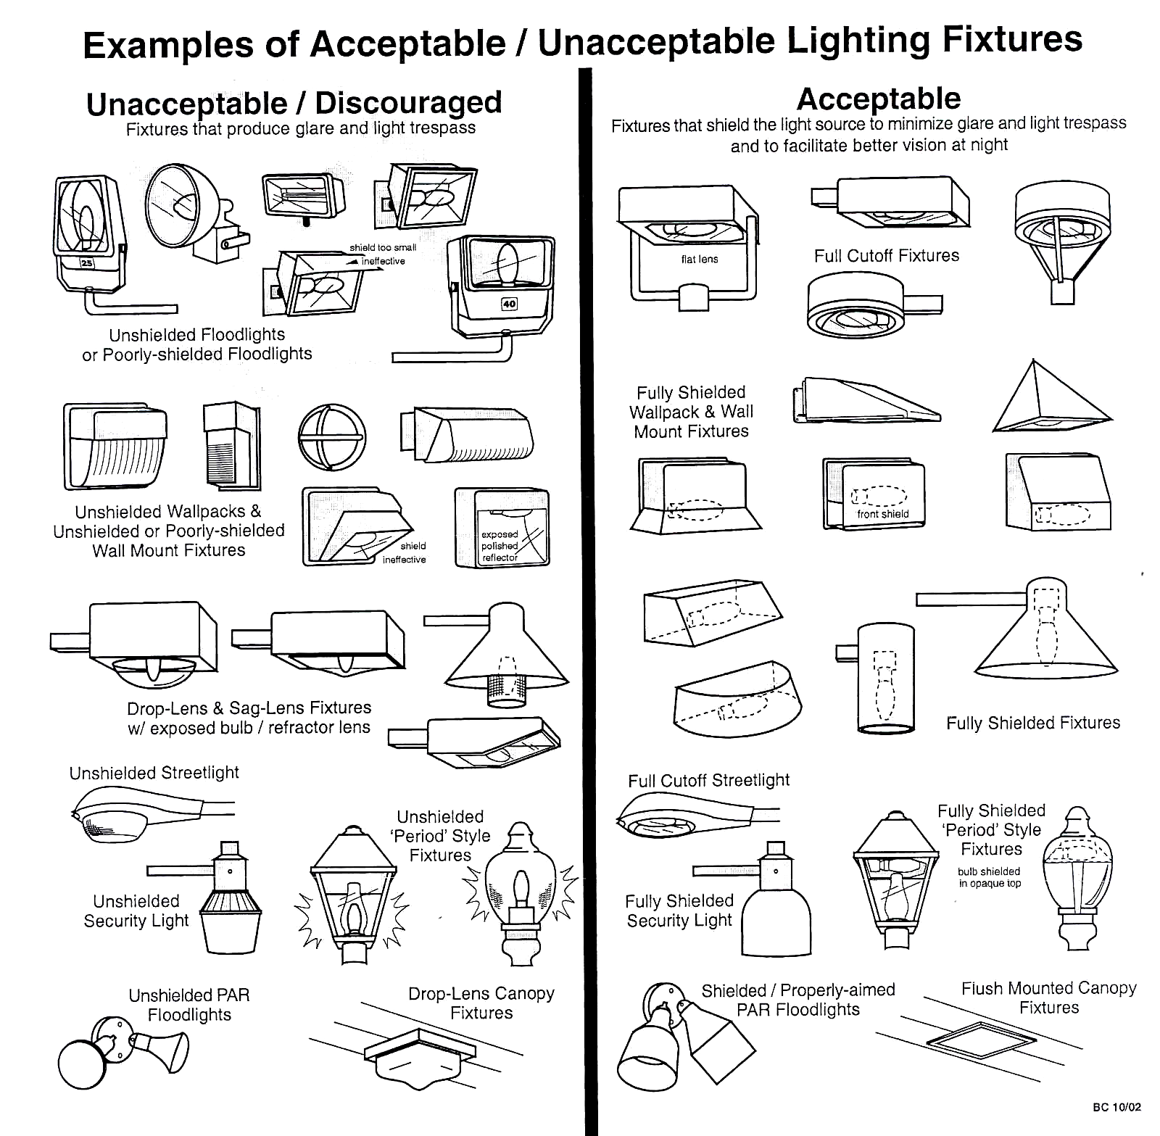

END AMENDMENT
PASSED AND ADOPTED THIS 11th DAY OF JUNE, 2008.

_____________________ _______________________ _____________________
Manuel Ruiz, Chairman Robert Damon, District 1 John Maynard, District 3

ATTEST:

______________________________
Melinda Meek, Clerk of the Board

APPROVED AS TO FORM:

__________________________________
Luis Parra, Deputy County Attorney, Civil

